Rushmere St Andrew Neighbourhood Plan Questionnaire Results
  - January 2021
LANDSCAPE AND ENVIRONMENT

1. Please indicate your preference by ticking one box in response to the statements below
 | Strongly Agree | Agree | Disagree | Strongly Disagree | No view | Response Total
It is important to preserve the landscape features of Rushmere St Andrew | 82.7%  (182) | 15.5%  (34) | 0.5%  (1) | 0.0%  (0) | 1.4%  (3) | 220
Rushmere Heath should be preserved as Common Land | 92.7%  (202) | 6.4%  (14) | 0.5%  (1) | 0.0%  (0) | 0.5%  (1) | 218
Protecting and preserving trees, hedgerows and ponds should be sought where appropriate in planning applications | 85.0%  (187) | 13.6%  (30) | 0.5%  (1) | 0.0%  (0) | 0.9%  (2) | 220
It is important to retain and maintain the Sandlings and Millstream Local Nature Reserves | 92.2%  (202) | 7.3%  (16) | 0.0%  (0) | 0.0%  (0) | 0.5%  (1) | 219
The Parish Council has a duty to work with local landowners and relevant authorities to maintain the environment in the parish | 75.5%  (166) | 23.2%  (51) | 0.0%  (0) | 0.0%  (0) | 1.4%  (3) | 220
Open view across fields and woods are important assets to be protected | 74.2%  (161) | 18.4%  (40) | 3.7%  (8) | 0.0%  (0) | 3.7%  (8) | 217
Land currently set aside for sports grounds should be protected from development | 71.2%  (156) | 21.9%  (48) | 4.1%  (9) | 0.5%  (1) | 2.3%  (5) | 219
Footpaths are a vital part of the local landscape and environment | 88.6%  (194) | 10.5%  (23) | 0.5%  (1) | 0.0%  (0) | 0.5%  (1) | 219
It is important to retain a "buffer zone" between Ipswich and Rushmere St Andrew | 68.7%  (149) | 18.9%  (41) | 6.5%  (14) | 0.9%  (2) | 5.1%  (11) | 217
Public open spaces (such as the Sandlings) are vital to the well being of parishioners | 83.6%  (184) | 14.5%  (32) | 0.5%  (1) | 0.0%  (0) | 1.4%  (3) | 220
The Village Allotments should be preserved from being developed | 65.5%  (144) | 23.2%  (51) | 4.1%  (9) | 0.0%  (0) | 7.3%  (16) | 220
I support the development of Quiet Lanes (Lamberts Lane, Tuddenham Lane, Playford Lane, Holly Lane, Severn Cottages Lane). Quiet Lanes means motorists must drive with additional caution such as slower speeds. | 55.7%  (122) | 27.9%  (61) | 5.5%  (12) | 3.7%  (8) | 7.3%  (16) | 219
Rushmere St Andrew Parish Council should continue to oppose any future plans for the Ipswich Northern Bypass | 44.0%  (96) | 14.7%  (32) | 18.8%  (41) | 11.0%  (24) | 11.5%  (25) | 218
 |  |  |  |  | answered | 220
 |  |  |  |  | skipped | 5

Matrix Charts

1.1. It is important to preserve the landscape features of Rushmere St Andrew |  |  | Response Percent | Response Total
1 | Strongly Agree |  | 82.7% | 182
2 | Agree |  | 15.5% | 34
3 | Disagree |  | 0.5% | 1
4 | Strongly Disagree |  | 0.0% | 0
5 | No view |  | 1.4% | 3
 |  |  | answered | 220

1.2. Rushmere Heath should be preserved as Common Land |  |  | Response Percent | Response Total
1 | Strongly Agree |  | 92.7% | 202
2 | Agree |  | 6.4% | 14
3 | Disagree |  | 0.5% | 1
4 | Strongly Disagree |  | 0.0% | 0
5 | No view |  | 0.5% | 1
 |  |  | answered | 218

1.3. Protecting and preserving trees, hedgerows and ponds should be sought where appropriate in planning applications |  |  | Response Percent | Response Total
1 | Strongly Agree |  | 85.0% | 187
2 | Agree |  | 13.6% | 30
3 | Disagree |  | 0.5% | 1
4 | Strongly Disagree |  | 0.0% | 0
5 | No view |  | 0.9% | 2
 |  |  | answered | 220

1.4. It is important to retain and maintain the Sandlings and Millstream Local Nature Reserves |  |  | Response Percent | Response Total
1 | Strongly Agree |  | 92.2% | 202
2 | Agree |  | 7.3% | 16
3 | Disagree |  | 0.0% | 0
4 | Strongly Disagree |  | 0.0% | 0
5 | No view |  | 0.5% | 1
 |  |  | answered | 219

1.5. The Parish Council has a duty to work with local landowners and relevant authorities to maintain the environment in the parish |  |  | Response Percent | Response Total
1 | Strongly Agree |  | 75.5% | 166
2 | Agree |  | 23.2% | 51
3 | Disagree |  | 0.0% | 0
4 | Strongly Disagree |  | 0.0% | 0
5 | No view |  | 1.4% | 3
 |  |  | answered | 220

1.6. Open view across fields and woods are important assets to be protected |  |  | Response Percent | Response Total
1 | Strongly Agree |  | 74.2% | 161
2 | Agree |  | 18.4% | 40
3 | Disagree |  | 3.7% | 8
4 | Strongly Disagree |  | 0.0% | 0
5 | No view |  | 3.7% | 8
 |  |  | answered | 217

1.7. Land currently set aside for sports grounds should be protected from development |  |  | Response Percent | Response Total
1 | Strongly Agree |  | 71.2% | 156
2 | Agree |  | 21.9% | 48
3 | Disagree |  | 4.1% | 9
4 | Strongly Disagree |  | 0.5% | 1
5 | No view |  | 2.3% | 5
 |  |  | answered | 219

1.8. Footpaths are a vital part of the local landscape and environment |  |  | Response Percent | Response Total
1 | Strongly Agree |  | 88.6% | 194
2 | Agree |  | 10.5% | 23
3 | Disagree |  | 0.5% | 1
4 | Strongly Disagree |  | 0.0% | 0
5 | No view |  | 0.5% | 1
 |  |  | answered | 219

1.9. It is important to retain a "buffer zone" between Ipswich and Rushmere St Andrew |  |  | Response Percent | Response Total
1 | Strongly Agree |  | 68.7% | 149
2 | Agree |  | 18.9% | 41
3 | Disagree |  | 6.5% | 14
4 | Strongly Disagree |  | 0.9% | 2
5 | No view |  | 5.1% | 11
 |  |  | answered | 217

1.10. Public open spaces (such as the Sandlings) are vital to the well being of parishioners |  |  | Response Percent | Response Total
1 | Strongly Agree |  | 83.6% | 184
2 | Agree |  | 14.5% | 32
3 | Disagree |  | 0.5% | 1
4 | Strongly Disagree |  | 0.0% | 0
5 | No view |  | 1.4% | 3
 |  |  | answered | 220

1.11. The Village Allotments should be preserved from being developed |  |  | Response Percent | Response Total
1 | Strongly Agree |  | 65.5% | 144
2 | Agree |  | 23.2% | 51
3 | Disagree |  | 4.1% | 9
4 | Strongly Disagree |  | 0.0% | 0
5 | No view |  | 7.3% | 16
 |  |  | answered | 220

1.12. I support the development of Quiet Lanes (Lamberts Lane, Tuddenham Lane, Playford Lane, Holly Lane, Severn Cottages Lane). Quiet Lanes means motorists must drive with additional caution such as slower speeds. |  |  | Response Percent | Response Total
1 | Strongly Agree |  | 55.7% | 122
2 | Agree |  | 27.9% | 61
3 | Disagree |  | 5.5% | 12
4 | Strongly Disagree |  | 3.7% | 8
5 | No view |  | 7.3% | 16
 |  |  | answered | 219

1.13. Rushmere St Andrew Parish Council should continue to oppose any future plans for the Ipswich Northern Bypass |  |  | Response Percent | Response Total
1 | Strongly Agree |  | 44.0% | 96
2 | Agree |  | 14.7% | 32
3 | Disagree |  | 18.8% | 41
4 | Strongly Disagree |  | 11.0% | 24
5 | No view |  | 11.5% | 25
 |  |  | answered | 218

HOUSING

3. Do you intend to remain living in Rushmere St Andrew for the foreseeable future?
 |  |  | Response Percent | Response Total
1 | Yes |  | 95.00% | 209
2 | No |  | 0.45% | 1
3 | Not sure |  | 4.55% | 10
 |  |  | answered | 220
 |  |  | skipped | 5

4. When you think about the future is it likely that your future housing needs could be met within the parish?
 |  |  | Response Percent | Response Total
1 | Yes |  | 78.64% | 173
2 | No |  | 5.00% | 11
3 | Not sure |  | 16.36% | 36
 |  |  | answered | 220
 |  |  | skipped | 5

5. If new housing were to be built in Rushmere St Andrew what type of housing do you feel is most needed? Please select one or more of the following:
 |  |  | Response Percent | Response Total
1 | Homes for single occupancy (e.g. 1 or 2 bedroom units) |  | 20.83% | 45
2 | Starter homes (e.g. 2 or 3 bedroom units) |  | 58.80% | 127
3 | Large family/ executive homes (e.g. 4 plus bedroom units) |  | 31.48% | 68
4 | Retirement homes/ sheltered accommodation (e.g. bungalows) |  | 62.04% | 134
5 | Affordable/ Social housing |  | 22.22% | 48
 |  |  | answered | 216
 |  |  | skipped | 9

6. When new housing developments are built how important do you feel the following requirements are? Please select one or more of the following:
 |  |  | Response Percent | Response Total
1 | Homes built with sustainable energy/ low carbon technology e.g. solar panels |  | 74.09% | 163
2 | Front and back gardens |  | 74.09% | 163
3 | Driveways big enough for at least 2 off road car parking spaces |  | 80.91% | 178
4 | Electric car charging points |  | 57.73% | 127
5 | More dense development to protect undeveloped land |  | 6.82% | 15
6 | Street designs that slow down car speeds |  | 48.18% | 106
7 | Public green spaces within developments |  | 81.82% | 180
8 | Footpaths for safe pedestrian access |  | 86.36% | 190
9 | Cycle paths |  | 60.45% | 133
10 | Planting native species trees and hedges |  | 74.09% | 163
11 | Provision of hedgehog holes in perimeter fences |  | 51.36% | 113
 |  |  | answered | 220
 |  |  | skipped | 5

7. What type of housing developments do you feel would be acceptable in the parish? Please select one or more of the following:
 |  |  | Response Percent | Response Total
1 | Small scale housing developments (10 units or less) |  | 54.09% | 119
2 | Medium housing developments (up to 35 units) |  | 29.09% | 64
3 | Large scale developments (35 plus units) |  | 6.36% | 14
4 | I agree with the current planning policy which is against "back (garden)" development |  | 46.82% | 103
5 | I don’t feel there is a need for any additional housing development in the parish |  | 28.18% | 62
 |  |  | answered | 220
 |  |  | skipped | 5

8. Are there any sites in the parish you feel would be SUITABLE for housing development?
 |  |  | Response Percent | Response Total
1 | Yes |  | 13.30% | 29
2 | No |  | 26.15% | 57
3 | Not sure |  | 60.55% | 132
 |  |  | answered | 218
 |  |  | skipped | 7

13. Regarding INFRASTUCTURE where you live. Do you feel that any of the following services etc would need to be upgraded if housing development were planned? Please tick one or more:
 |  |  | Response Percent | Response Total
1 | Water Mains/ Water Resources |  | 27.64% | 55
2 | Sewers |  | 32.16% | 64
3 | Electricity Supply |  | 17.09% | 34
4 | Gas Mains |  | 16.08% | 32
5 | Surface Water Drainage |  | 43.22% | 86
6 | Broadband Service |  | 49.75% | 99
7 | Mobile Phone Signals |  | 27.14% | 54
8 | Additional School Places |  | 57.29% | 114
9 | Additional Doctors |  | 70.35% | 140
10 | Improved Shopping Facilities |  | 35.68% | 71
 |  |  | answered | 199
 |  |  | skipped | 26

14. Please comment on the statement: "All new housing should be designed to match existing house styles in that location"
 |  |  | Response Percent | Response Total
1 | Strongly Agree |  | 29.22% | 64
2 | Agree |  | 36.99% | 81
3 | Disagree |  | 17.81% | 39
4 | Strongly Disagree |  | 4.11% | 9
5 | No view |  | 11.87% | 26
 |  |  | answered | 219
 |  |  | skipped | 6

ROADS AND TRANSPORT

16. Which of the following give you cause for concern in the parish? Please select one or more of the following:
 |  |  | Response Percent | Response Total
1 | Traffic speed |  | 54.59% | 119
2 | "Rat-run" traffic |  | 45.87% | 100
3 | School-run traffic including parking near school |  | 55.05% | 120
4 | Heavy Goods Vehicles |  | 22.02% | 48
5 | Narrow pavements |  | 25.23% | 55
6 | Cyclists |  | 12.84% | 28
7 | Pedestrians |  | 3.67% | 8
8 | Parking on pavements |  | 52.75% | 115
9 | Parking on grass verges |  | 45.41% | 99
10 | I don’t have any concerns regarding traffic |  | 6.42% | 14
 |  |  | answered | 218
 |  |  | skipped | 7

18. Which of the following do you feel would be most effective in reducing the speed and volume of traffic in the parish? Please select one or more of the following:
 |  |  | Response Percent | Response Total
1 | Improved signage of speed limits |  | 32.00% | 64
2 | Traffic calming measures through The Street, Rushmere Village either by restricted width carriage and/or speed reducing road cushions (vehicle "friendly" speed humps) |  | 29.50% | 59
3 | Restricting through traffic in The Street, Rushmere Village with the use of "access only" signs at either end of the village |  | 18.50% | 37
4 | Introducing vehicle weight restrictions through Rushmere Village |  | 26.50% | 53
5 | Introducing Quiet Lanes to specified roads in the village. Quiet Lanes means motorists must drive with additional caution such as slower speeds. |  | 34.00% | 68
6 | Introducing "School Street" regulations to close sections of roads near school run times |  | 26.00% | 52
7 | Flashing 20 mph signs at school run time (close to Broke Hall school and to include section of Foxhall Road) |  | 49.50% | 99
8 | Traffic calming measures on Arundel Way either by restricting flow and or speed reducing road cushions |  | 24.50% | 49
9 | Introducing vehicle weight restrictions through Broke Hall Estate |  | 21.50% | 43
10 | Using "Smiley Face" or "Red/Green" Speed Indicator Devices at known "problem spots" in Rushmere St Andrew which are affected by speeding |  | 59.00% | 118
 |  |  | answered | 200
 |  |  | skipped | 25

20. What is the mode of transport you normally use for most of your work journeys? Please select one:
 |  |  | Response Percent | Response Total
1 | Car/ Van/ Works Vehicle/ Private Vehicle |  | 40.64% | 89
2 | Motorcycle/ Moped/ Scooter |  | 0.91% | 2
3 | Cycle |  | 5.02% | 11
4 | Walk |  | 3.20% | 7
5 | Public Transport/ Community Bus |  | 0.91% | 2
6 | Taxi/ Specially adapted transport/ Works Transport |  | 0.00% | 0
7 | I work from home |  | 11.42% | 25
8 | I am retired / not currently in work |  | 37.90% | 83
 |  |  | answered | 219
 |  |  | skipped | 6

21. What is your normal mode of transport for shopping journeys? Please select one of the following:
 |  |  | Response Percent | Response Total
1 | Car/ Van/ Works Vehicle/ Private Vehicle |  | 91.59% | 196
2 | Motorcycle/ Moped/ Scooter |  | 0.00% | 0
3 | Cycle |  | 1.87% | 4
4 | Walk |  | 3.74% | 8
5 | Public Transport/ Community Bus |  | 2.80% | 6
6 | Taxi/ Specially adapted transport/ Works Transport |  | 0.00% | 0
 |  |  | answered | 214
 |  |  | skipped | 11

22. Public Transport - Please select ONE of the following which best describes your frequency of use:
 |  |  | Response Percent | Response Total
1 | Daily/ several times a week |  | 4.13% | 9
2 | Once a week |  | 12.84% | 28
3 | Once a month or so |  | 9.63% | 21
4 | Only a few times a year |  | 29.36% | 64
5 | Rarely or never |  | 44.04% | 96
 |  |  | answered | 218
 |  |  | skipped | 7

PARISH AMENITIES AND SERVICES

25. Please indicate your use of the following. This could be for yourself or with a family member. Please use the appropriate initial corresponding to your selection:
 | Daily or several times a week | Once a week | Once or twice per month | A few times a year | Never | Response Total
Chestnut Play Area | 1.0%  (2) | 1.0%  (2) | 2.6%  (5) | 12.4%  (24) | 82.9%  (160) | 193
Picnic table or seats at Chestnut Pond | 0.5%  (1) | 2.1%  (4) | 4.2%  (8) | 20.3%  (39) | 72.9%  (140) | 192
Tower Hall Play Area (including adult equipment) | 0.5%  (1) | 6.5%  (13) | 9.0%  (18) | 22.4%  (45) | 61.7%  (124) | 201
Kelvedon Play Space | 1.1%  (2) | 1.6%  (3) | 0.0%  (0) | 8.6%  (16) | 88.7%  (165) | 186
Yew Tree Play Area | 1.6%  (3) | 0.5%  (1) | 0.0%  (0) | 1.1%  (2) | 96.8%  (180) | 186
Broke Hall Playing Field (includes adult equipment) | 0.5%  (1) | 3.1%  (6) | 6.8%  (13) | 17.8%  (34) | 71.7%  (137) | 191
Football (goals) area and/or seats on the Sandlings Public Open Space | 3.6%  (7) | 7.8%  (15) | 8.3%  (16) | 16.1%  (31) | 64.2%  (124) | 193
How often do you visit your plot if you are a tenant at Rushmere Allotments | 8.1%  (9) | 1.8%  (2) | 0.0%  (0) | 0.0%  (0) | 90.1%  (100) | 111
Although not a parish responsibility – how often do you visit Rushmere Heath | 35.8%  (77) | 16.3%  (35) | 15.3%  (33) | 25.1%  (54) | 7.4%  (16) | 215
 |  |  |  |  | answered | 217
 |  |  |  |  | skipped | 8
Any other areas in the parish (please specify) (39)

Matrix Charts

25.1. Chestnut Play Area |  |  | Response Percent | Response Total
1 | Daily or several times a week |  | 1.0% | 2
2 | Once a week |  | 1.0% | 2
3 | Once or twice per month |  | 2.6% | 5
4 | A few times a year |  | 12.4% | 24
5 | Never |  | 82.9% | 160
 |  |  | answered | 193

25.2. Picnic table or seats at Chestnut Pond |  |  | Response Percent | Response Total
1 | Daily or several times a week |  | 0.5% | 1
2 | Once a week |  | 2.1% | 4
3 | Once or twice per month |  | 4.2% | 8
4 | A few times a year |  | 20.3% | 39
5 | Never |  | 72.9% | 140
 |  |  | answered | 192

25.3. Tower Hall Play Area (including adult equipment) |  |  | Response Percent | Response Total
1 | Daily or several times a week |  | 0.5% | 1
2 | Once a week |  | 6.5% | 13
3 | Once or twice per month |  | 9.0% | 18
4 | A few times a year |  | 22.4% | 45
5 | Never |  | 61.7% | 124
 |  |  | answered | 201

25.4. Kelvedon Play Space |  |  | Response Percent | Response Total
1 | Daily or several times a week |  | 1.1% | 2
2 | Once a week |  | 1.6% | 3
3 | Once or twice per month |  | 0.0% | 0
4 | A few times a year |  | 8.6% | 16
5 | Never |  | 88.7% | 165
 |  |  | answered | 186

25.5. Yew Tree Play Area |  |  | Response Percent | Response Total
1 | Daily or several times a week |  | 1.6% | 3
2 | Once a week |  | 0.5% | 1
3 | Once or twice per month |  | 0.0% | 0
4 | A few times a year |  | 1.1% | 2
5 | Never |  | 96.8% | 180
 |  |  | answered | 186

25.6. Broke Hall Playing Field (includes adult equipment) |  |  | Response Percent | Response Total
1 | Daily or several times a week |  | 0.5% | 1
2 | Once a week |  | 3.1% | 6
3 | Once or twice per month |  | 6.8% | 13
4 | A few times a year |  | 17.8% | 34
5 | Never |  | 71.7% | 137
 |  |  | answered | 191

25.7. Football (goals) area and/or seats on the Sandlings Public Open Space |  |  | Response Percent | Response Total
1 | Daily or several times a week |  | 3.6% | 7
2 | Once a week |  | 7.8% | 15
3 | Once or twice per month |  | 8.3% | 16
4 | A few times a year |  | 16.1% | 31
5 | Never |  | 64.2% | 124
 |  |  | answered | 193

25.8. How often do you visit your plot if you are a tenant at Rushmere Allotments |  |  |  |  | Response Percent | Response Total
1 | Daily or several times a week |  |  |  | 8.1% | 9
2 | Once a week |  |  |  | 1.8% | 2
3 | Once or twice per month |  |  |  | 0.0% | 0
4 | A few times a year |  |  |  | 0.0% | 0
5 | Never |  |  |  | 90.1% | 100
 |  |  |  |  | answered | 111
25.9. Although not a parish responsibility – how often do you visit Rushmere Heath |  |  |  |  | Response Percent | Response Total
1 |  | Daily or several times a week |  |  | 35.8% | 77
2 |  | Once a week |  |  | 16.3% | 35
3 |  | Once or twice per month |  |  | 15.3% | 33
4 |  | A few times a year |  |  | 25.1% | 54
5 |  | Never |  |  | 7.4% | 16
 |  |  |  |  | answered | 215

26. The Parish Council is solely or jointly responsible for the upkeep and appearance of the amenities and facilities in the parish. Please indicate Yes, No or No View below:
 | Yes | No | No View | Response Total
Is the equipment maintained in good order? | 55.0%  (120) | 0.5%  (1) | 44.5%  (97) | 218
Are the facilities kept clean and tidy? | 57.8%  (126) | 4.1%  (9) | 38.1%  (83) | 218
Are there sufficient litter bins? | 42.9%  (94) | 30.1%  (66) | 26.9%  (59) | 219
Are there sufficient dog poo bins? | 39.3%  (86) | 26.5%  (58) | 34.2%  (75) | 219
Have we catered sufficiently for disabled users? | 18.1%  (39) | 10.7%  (23) | 71.2%  (153) | 215
Do you feel there is good access to all sites? | 57.4%  (124) | 4.6%  (10) | 38.0%  (82) | 216
 |  |  | answered | 220
 |  |  | skipped | 5

6.1. Is the equipment maintained in good order? |  |  | Response Percent | Response Total
1 | Yes |  | 55.0% | 120
2 | No |  | 0.5% | 1
3 | No View |  | 44.5% | 97
 |  |  | answered | 218

26.2. Are the facilities kept clean and tidy? |  |  | Response Percent | Response Total
1 | Yes |  | 57.8% | 126
2 | No |  | 4.1% | 9
3 | No View |  | 38.1% | 83
 |  |  | answered | 218

26.3. Are there sufficient litter bins? |  |  | Response Percent | Response Total
1 | Yes |  | 42.9% | 94
2 | No |  | 30.1% | 66
3 | No View |  | 26.9% | 59
 |  |  | answered | 219

26.4. Are there sufficient dog poo bins? |  |  | Response Percent | Response Total
1 | Yes |  | 39.3% | 86
2 | No |  | 26.5% | 58
3 | No View |  | 34.2% | 75
 |  |  | answered | 219

26.5. Have we catered sufficiently for disabled users? |  |  | Response Percent | Response Total
1 | Yes |  | 18.1% | 39
2 | No |  | 10.7% | 23
3 | No View |  | 71.2% | 153
 |  |  | answered | 215

26.6. Do you feel there is good access to all sites? |  |  | Response Percent | Response Total
1 | Yes |  | 57.4% | 124
2 | No |  | 4.6% | 10
3 | No View |  | 38.0% | 82
 |  |  | answered | 216

28. Do you think any of the following is needed? Please tick the appropriate box:
 | Yes | No | Not Sure | Response Total
More adult exercise equipment | 24.0%  (50) | 36.5%  (76) | 39.4%  (82) | 208
More recreational equipment for older children / youths in existing play areas | 46.0%  (97) | 18.0%  (38) | 36.0%  (76) | 211
A football play area in Rushmere Village | 29.2%  (61) | 14.8%  (31) | 56.0%  (117) | 209
Additional facilities for disabled users | 27.9%  (57) | 8.8%  (18) | 63.2%  (129) | 204
Sensory facilities for visually impaired and those hard of hearing | 32.8%  (66) | 7.0%  (14) | 60.2%  (121) | 201
 |  |  | answered | 215
 |  |  | skipped | 10

28.1. More adult exercise equipment |  |  | Response Percent | Response Total
1 | Yes |  | 24.0% | 50
2 | No |  | 36.5% | 76
3 | Not Sure |  | 39.4% | 82
 |  |  | answered | 208

28.2. More recreational equipment for older children / youths in existing play areas |  |  | Response Percent | Response Total
1 | Yes |  | 46.0% | 97
2 | No |  | 18.0% | 38
3 | Not Sure |  | 36.0% | 76
 |  |  | answered | 211

28.3. A football play area in Rushmere Village |  |  | Response Percent | Response Total
1 | Yes |  | 29.2% | 61
2 | No |  | 14.8% | 31
3 | Not Sure |  | 56.0% | 117
 |  |  | answered | 209

28.4. Additional facilities for disabled users |  |  | Response Percent | Response Total
1 | Yes |  | 27.9% | 57
2 | No |  | 8.8% | 18
3 | Not Sure |  | 63.2% | 129
 |  |  | answered | 204

28.5. Sensory facilities for visually impaired and those hard of hearing |  |  | Response Percent | Response Total
1 | Yes |  | 32.8% | 66
2 | No |  | 7.0% | 14
3 | Not Sure |  | 60.2% | 121
 |  |  | answered | 201

30. Rushmere St Andrew Parish Council is keen to ensure that the many footpaths which cross the parish are maintained in good order. It should be noted that footpaths cross land which is owned by private landowners, local farmers, utility companies, building developers etc. Suffolk County Council takes the principal role in respect of maintaining "public rights of way". Please tick appropriate box:
 | Yes | No | Response Total
I regularly walk footpaths in the parish | 85.5%  (183) | 14.5%  (31) | 214
I am familiar with the footpath routes in the parish | 83.5%  (182) | 16.5%  (36) | 218
I am familiar with the Jubilee Walk in the parish | 76.9%  (166) | 23.1%  (50) | 216
Walking the footpaths is an essential part of my well-being | 84.5%  (180) | 15.5%  (33) | 213
The footpaths I use are maintained in good order | 85.0%  (176) | 15.0%  (31) | 207
I rarely (or never) use parish footpaths | 12.6%  (21) | 87.4%  (146) | 167
I would use footpaths if they were better signposted | 46.4%  (71) | 53.6%  (82) | 153
I would use footpaths more if there were routes marked out with distance and time indications/ accessibility | 54.0%  (88) | 46.0%  (75) | 163
I feel safe walking anywhere in the parish | 87.4%  (180) | 12.6%  (26) | 206
 |  | answered | 220
 |  | skipped | 5

30.1. I regularly walk footpaths in the parish |  |  | Response Percent | Response Total
1 | Yes |  | 85.5% | 183
2 | No |  | 14.5% | 31
 |  |  | answered | 214

30.2. I am familiar with the footpath routes in the parish |  |  | Response Percent | Response Total
1 | Yes |  | 83.5% | 182
2 | No |  | 16.5% | 36
 |  |  | answered | 218

30.3. I am familiar with the Jubilee Walk in the parish |  |  | Response Percent | Response Total
1 | Yes |  | 76.9% | 166
2 | No |  | 23.1% | 50
 |  |  | answered | 216

30.4. Walking the footpaths is an essential part of my well-being |  |  | Response Percent | Response Total
1 | Yes |  | 84.5% | 180
2 | No |  | 15.5% | 33
 |  |  | answered | 213

30.5. The footpaths I use are maintained in good order |  |  | Response Percent | Response Total
1 | Yes |  | 85.0% | 176
2 | No |  | 15.0% | 31
 |  |  | answered | 207

30.6. I rarely (or never) use parish footpaths |  |  | Response Percent | Response Total
1 | Yes |  | 12.6% | 21
2 | No |  | 87.4% | 146
 |  |  | answered | 167

30.7. I would use footpaths if they were better signposted |  |  | Response Percent | Response Total
1 | Yes |  | 46.4% | 71
2 | No |  | 53.6% | 82
 |  |  | answered | 153

30.8. I would use footpaths more if there were routes marked out with distance and time indications/ accessibility |  |  | Response Percent | Response Total
1 | Yes |  | 54.0% | 88
2 | No |  | 46.0% | 75
 |  |  | answered | 163

30.9. I feel safe walking anywhere in the parish |  |  | Response Percent | Response Total
1 | Yes |  | 87.4% | 180
2 | No |  | 12.6% | 26
 |  |  | answered | 206

ABOUT YOURSELF

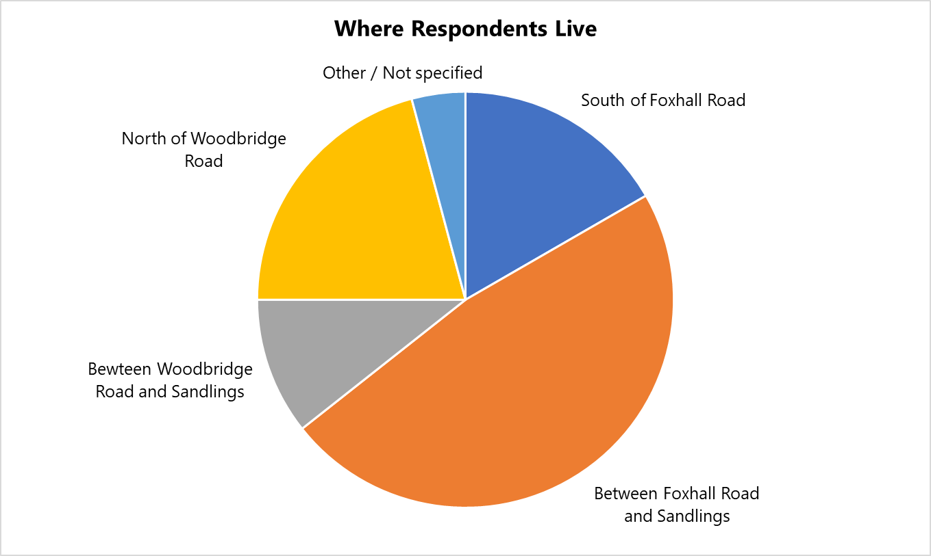
3. How long have you lived in Rushmere St Andrew (whole number to the nearest year)?
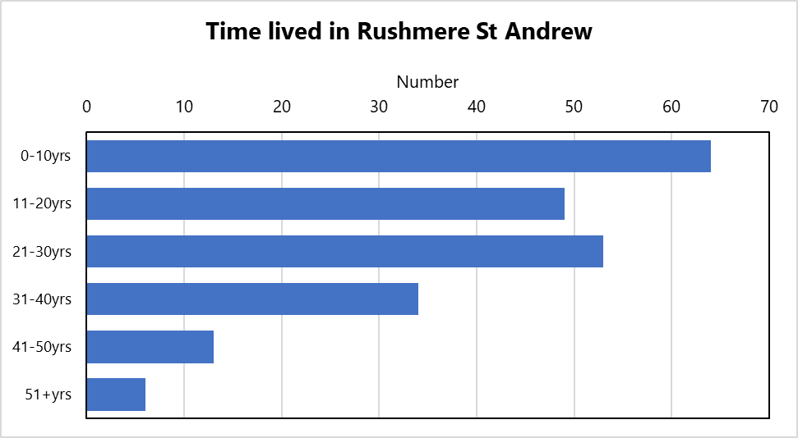

34. Please mark the appropriate box for you age:
 |  |  | Response Percent | Response Total
1 | 18 – 39 (there is a separate questionnaire for those aged up to 18) |  | 7.31% | 16
2 | 40-59 |  | 42.01% | 92
3 | Over 60 |  | 48.86% | 107
4 | Prefer not to say |  | 1.83% | 4
 |  |  | answered | 219
 |  |  | skipped | 6

35. Please mark that which applies to yourself
 |  |  | Response Percent | Response Total
1 | Employed (full or part-time) including self employed |  | 58.26% | 127
2 | Seeking employment |  | 0.00% | 0
3 | Student |  | 0.00% | 0
4 | Retired |  | 38.99% | 85
5 | Prefer not to say |  | 2.75% | 6
 |  |  | answered | 218
 |  |  | skipped | 7

36. For those in employment and self-employed please mark with the appropriate box relevant to your normal daily routine.
 |  |  | Response Percent | Response Total
1 | I work from home |  | 28.00% | 35
2 | My place of employment is in the parish |  | 5.60% | 7
3 | I travel to work outside the parish |  | 66.40% | 83
 |  |  | answered | 125
 |  |  | skipped | 100

