KESGRAVE AND RUSHMERE ST. ANDREW
Partnership Funded PCSO Report – August 2021
By PCSO 3357 Eleanor Miles

Woodbridge Safer Neighbourhood Team

Welcome to my monthly Partnership Funded PCSO report for August 2021

UPDATES:

E-Scooters
A reoccurring issue throughout the county is E-Scooters. Currently it is against the law for e-scooters to be ridden on the pavement or public road – they can only be used on private land with the landowner’s permission. E-scooters are classified as Personal Light Electric Vehicles and therefore are subjected to the same legal requirements as motor vehicles. Whilst certain areas of the UK are allowing rental scooters trials in line with government guidance, Suffolk is currently not one of these areas.

Those seen riding an e-scooter in a public place could face penalty points on your driver’s license and a fine for no insurance, in addition to your e-scooter being seized. You can also be prosecuted for other traffic offences including careless driving, drink/drug driving and speeding. I have been patrolling the local area and giving words of advice to anyone with an e-scooter in a public place. Should you have any concerns over E-scooter use, please report this through the official channels below.

Engagements
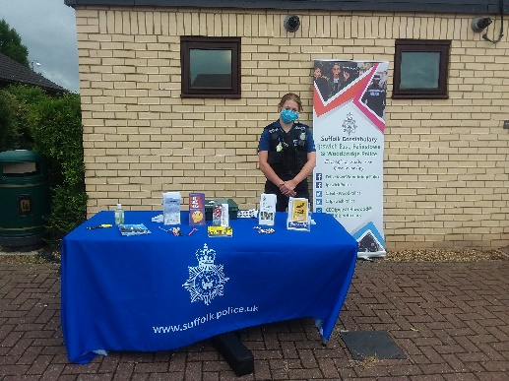
Over the last few months, I have been able to partake in a few engagements within the local community. I have been able to attend several organised events, such as Roller Skating outside the Kesgrave Scout Hut and the Kesgrave Fun day. The local Community Engagement Officer and I have also been able to organise a couple of pop up engagements for the upcoming month:
- Friday 13th August – Pop Up outside the Penzance Road shops, 10:00 – 12:00.
- Friday 27th August – Bike Marking at Oak Meadow Park, Kesgrave, 13:00 – 16:00.
If you have any queries or are interesting in having your bike marked, please drop by and see us!

ASB Awareness Week
Between 19th – 25th August was ASB Awareness Week in conjunction with East Suffolk Council. Some of my colleagues and I, along with the Communities Officers from East Suffolk Council, attended several locations to educate the community about anti-social behaviour and how to report it. ASB can include anything from noise pollution and unruly behaviour to harassing behaviour and vehicle annoyance. Such issues can be reported to both to the police through the official channels below or to East Suffolk Council https://www.eastsuffolk.gov.uk/community/anti-social-behaviour/

Parking
In the last month, I have received multiple locations where there are concerns over parking, namely vehicles causing an unnecessary obstruction. I have been patrolling those locations and will continue to, offering words of advice and enforcing where necessary.

With the schools starting next month for the Autumn term, I have been composing letters to send out to each school on my area explaining the laws surrounding parking in that area and the consequences should drivers contravening this. Such laws and restrictions are put in place to keep everyone safe so please ensure you abide by them and park in a suitable safe and legal location.

POLICE ADVICE AND GUIDANCE

I am always happy to give advice and guidance where I can. If it is something that I cannot give an immediate answer to, I am ideally placed to seek advice from other professionals. Members of the public can find advice on many police-related matters on the Suffolk Constabulary website https://www.suffolk.police.uk and our First Principle Crime Prevention advice pages can be found at www.suffolk.police.uk/advice/crime-prevention-z

Remember – call 999 in an emergency or if there is a crime in progress, otherwise call 101 or report online via https://www.suffolk.police.uk/contact-us/report-something

Eleanor Miles
Police Community Support Officer 3357
Match funded PCSO for Kesgrave and Rushmere St. Andrew
Woodbridge SNT Base
Tel. 101 (non-emergency number)
eleanor.miles@suffolk.pnn.police.uk
www.suffolk.police.uk

