KESGRAVE AND RUSHMERE ST. ANDREW
Partnership Funded PCSO Report – March 2021
By PCSO 3357 Eleanor Miles

Woodbridge Safer Neighbourhood Team

Welcome to my monthly Partnership Funded PCSO report for March 2021

UPDATES:

Parking
I have recently been informed that there have been a couple of parking issues around Rushmere, including Broke Hall Primary. The other local PCSOs and I will be continuing to patrol these areas and advise/enforce where necessary.

Motor Vehicle Security
In recent months, there has been an increase in motor vehicle related offences around the East of Ipswich. There are many precautions owners can take to ensure your car is secure and protected. The general advice is to not leave anything on display in your vehicle, parking in a secure, well-lit area and keeping your keys in a safe place. Further security can include having your vehicle registration etched onto all the windows, noting down serial numbers of items such as dash cams and stereos and fitting security devices (such as a steering wheel lock).

Additionally, catalytic converters have some value, making them a target. As a method of prevention, in addition to parking in a secure area (or using CCTV and lighting if this is not possible), you can have your catalytic converter marked with your registration, meaning it is easier for it to be traced back to you should it ever be stolen.

Should you have any concerns or if you spot anything suspicious or out of the ordinary, please be sure to report this through the official channels.

POLICE ADVICE AND GUIDANCE

I am always happy to give advice and guidance where I can. If it is something that I cannot give an immediate answer too, I am ideally placed to seek advice from other professionals. Members of the public wanting advice on many police-related matters can be signposted to the Suffolk Constabulary website advice page at https://www.suffolk.police.uk/advice

Remember – call 999 in an emergency or if there is a crime in progress, otherwise call 101 or report online via https://www.suffolk.police.uk/contact-us/report-something

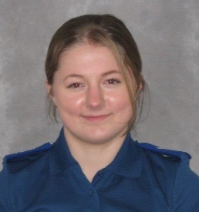
Eleanor Miles
Police Community Support Officer 3357
Match funded PCSO for Kesgrave and Rushmere St. Andrew
Woodbridge SNT Base
Tel. 101 (non-emergency number)
eleanor.miles@suffolk.pnn.police.uk
www.suffolk.police.uk

