KESGRAVE AND RUSHMERE ST. ANDREW
Partnership Funded PCSO Report – February 2021
By PCSO 3357 Eleanor Miles

Woodbridge Safer Neighbourhood Team

Welcome to my monthly Partnership Funded PCSO report for February 2021

UPDATES:

I have continued to patrol the key areas by foot and by car, including Broke Hall Primary School, Rushmere Heath and Broadlands Way, engaging with local residents where possible.

Speed Checks
Over the last month, I have been conducting speed checks in several key local areas, including Foxhall Road, Rushmere Road and Bell Lane. This resulted in the issuing of 2 fixed penalty notices and many cars given stopped for words of advice.

Rushmere Heath
Whilst we have not received any reports of anti-social behaviour in this area in the past month, the Heath remains one of the local priorities. This means that it is patrolled by local officers whenever possible, to intervene with any anti-social issues and potential breaches.

If you are aware of any anti-social issues within the community or wish to report any other police matter, please continue to do so through the relevant methods.

POLICE ADVICE AND GUIDANCE

I am always happy to give advice and guidance where I can. If it is something that I cannot give an immediate answer too, I am ideally placed to seek advice from other professionals. Members of the public wanting advice on many police-related matters can be signposted to the Suffolk Constabulary website advice page at https://www.suffolk.police.uk/advice

Remember – call 999 in an emergency or if there is a crime in progress, otherwise call 101 or report online via https://www.suffolk.police.uk/contact-us/report-something

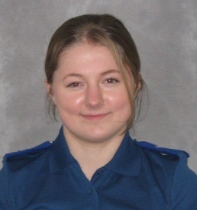
Eleanor Miles
Police Community Support Officer 3357
Match funded PCSO for Kesgrave and Rushmere St. Andrew
Woodbridge SNT Base
Tel. 101 (non-emergency number)
eleanor.miles@suffolk.pnn.police.uk
www.suffolk.police.uk

